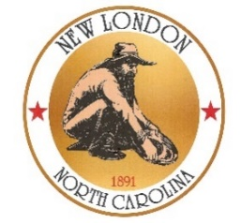
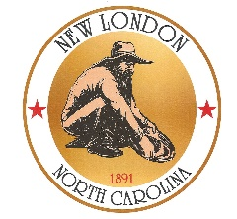
Town of
New London

Agenda for the Board of Commissioner’s Meeting
October 1, 2024, 7:00 PM

- Open Commissioner’s Meeting

- Pledge of Allegiance

- Receive items from visitors for agenda

1.
2.
3.

- Approve meeting agenda for 10-1-24

- Approve minutes of 9-3-24 Town Board Meeting

- Commissioner Peak:

- Water-Sewer Report
- Transportation Update

_______________________________________________
_______________________________________________

- Commissioner Chestnut:

- Code Enforcement Report
_______________________________________________

- Commissioner Kimmer:

_____________________________________________
_____________________________________________

- Commissioner Lanier:

_____________________________________________
_____________________________________________

- Commissioner Higgins:

- _____________________________________________
_____________________________________________

- Mrs. Almond:

- Audit Update
- Museum Update
- Carolina Thread Trail- Tom Webb Section Opening Friday, October 18th at 10am
- Trunk or Treat Event at the Park- Saturday, October 26th from 6pm-8pm
- Santa in the Park- Friday, December 6th from 6pm – 8pm
- Vacuum Leaf Collection- Monday, December 9th

- Mayor Daniels:

- Weekend Park Clean-up
- Golf Cart Guidelines

Adjourn

